1.Write a program that prints “Hello World!” to the screen.

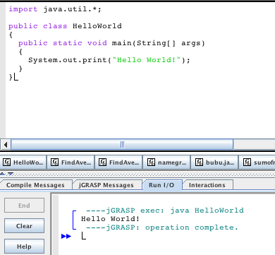

2. Write a program that asks the user for her name and greets her with her name.

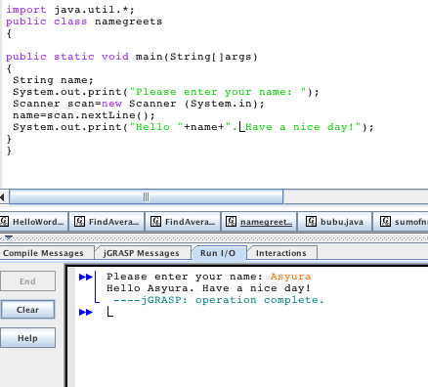

3. Modify the previous program such that only the users Alice and Bob are greeted with their names.

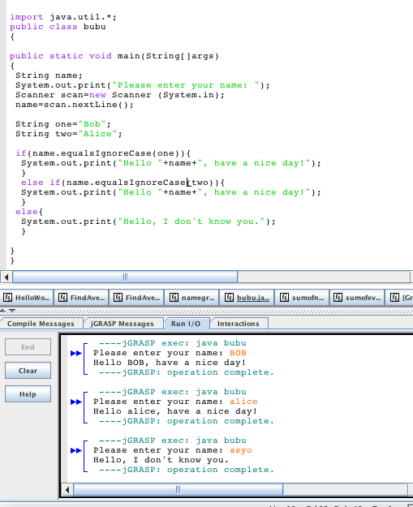

4. Write a program that asks the user for a number n and prints the sum of the numbers 1 to n

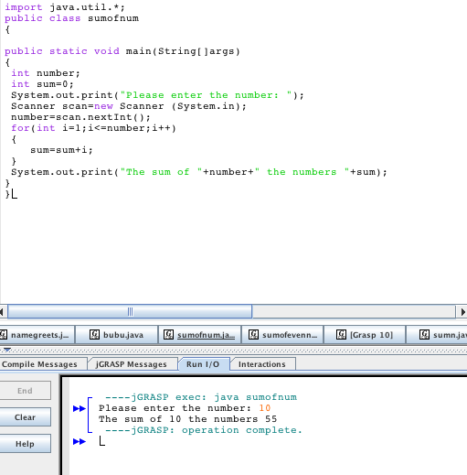

5. Modify the previous program such that only even numbers are considered in the sum e.g 3,5,6,9,10,12,15 for n=17.

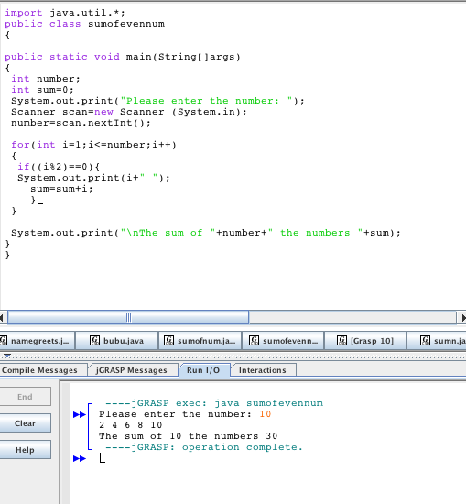

.

6. What is charAt()? Give one example.

charAt() returns the character located at the String's specified index. The string indexes start from zero.

For example,

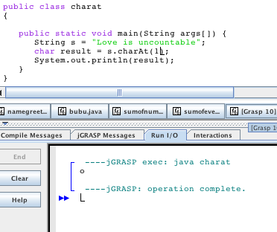

7. What is substring? Give one example.

This method has two variants and returns a new string that is a substring of this string.

For example,

